**EASY:**

1. Write a C++ program to declare and initialize a constant integer with value 10.

**Program:**

#include<iostream>

using namespace std;

int main(){

const int a=10;

cout<<"The value of constant is :"<<a;

}

**Output:**

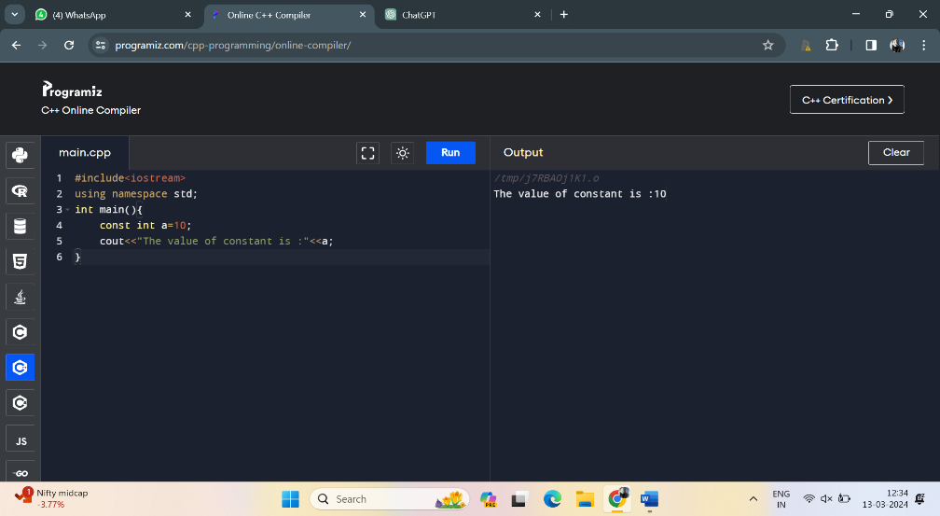

2. Write a C++ program to demonstrate the use of integer, float, and character data types

**Program:**

#include<iostream>

using namespace std;

int main(){

int a=10;

cout<<"integer data type is:"<<a<<"\n";

float b=3.14;

cout<<"float datatype is :"<<b<<"\n";

char c='A';

cout<<"character data type is:"<<c;

return 0;

}

**Output**:

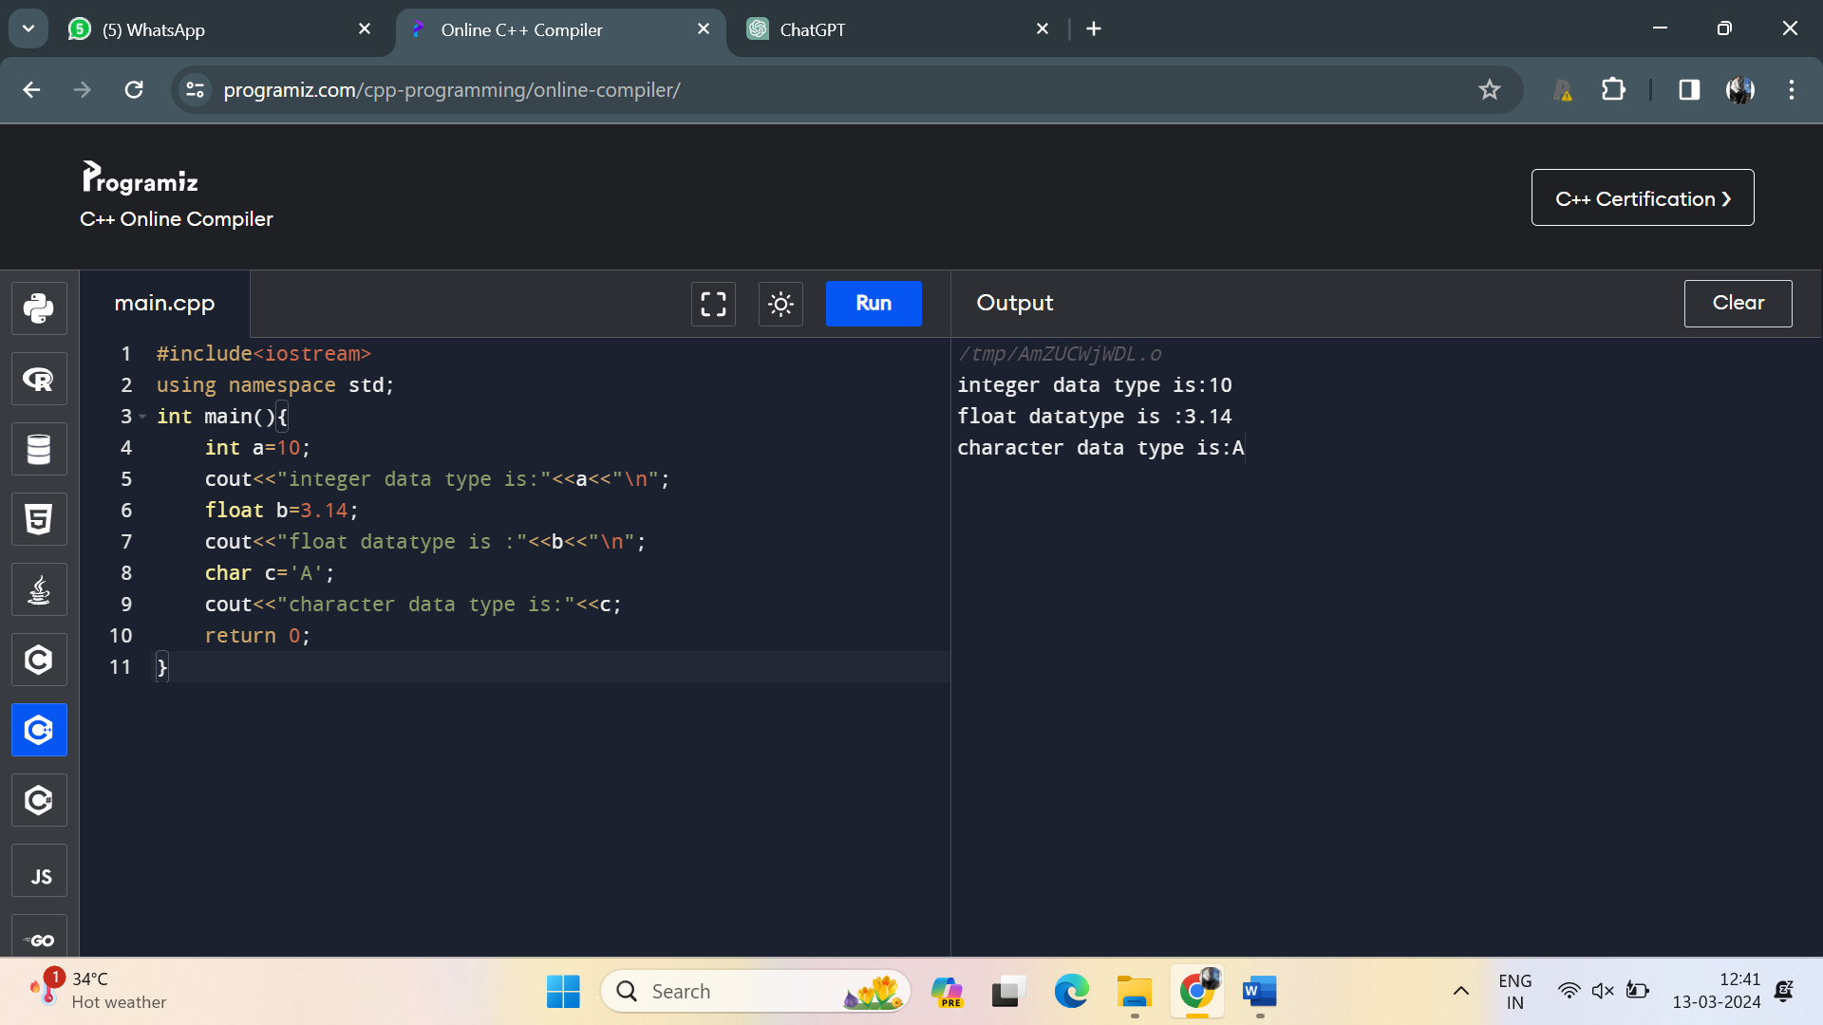

3. Create a C++ program to declare an integer variable and a float variable, then assign the integer variable to the float variable

**Program**:

#include<iostream>

using namespace std;

int main(){

int a=10;

float b;

b=static_cast<float>(a);

cout<<"integer value is:"<<a<<"\n";

cout<<"float value is :"<<b;

}

**Output**:

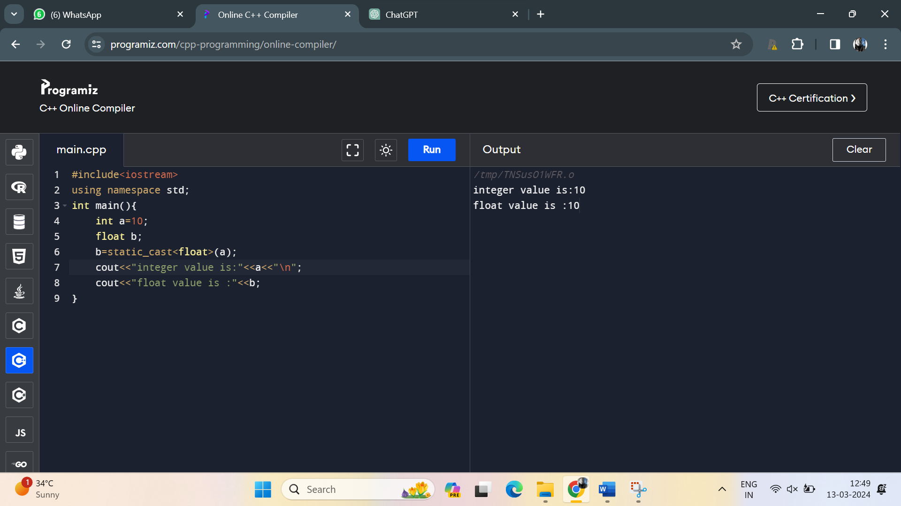

4. Implement a C++ program that performs an implicit conversion from integer to float

**Program**:

#include <iostream>

using namespace std;

int main() {

int myInteger = 42;

float myFloat = myInteger;

cout << "Integer value: " << myInteger << "\n";

cout << "Float value (after implicit conversion): " << myFloat ;

return 0;

}

**Output**:

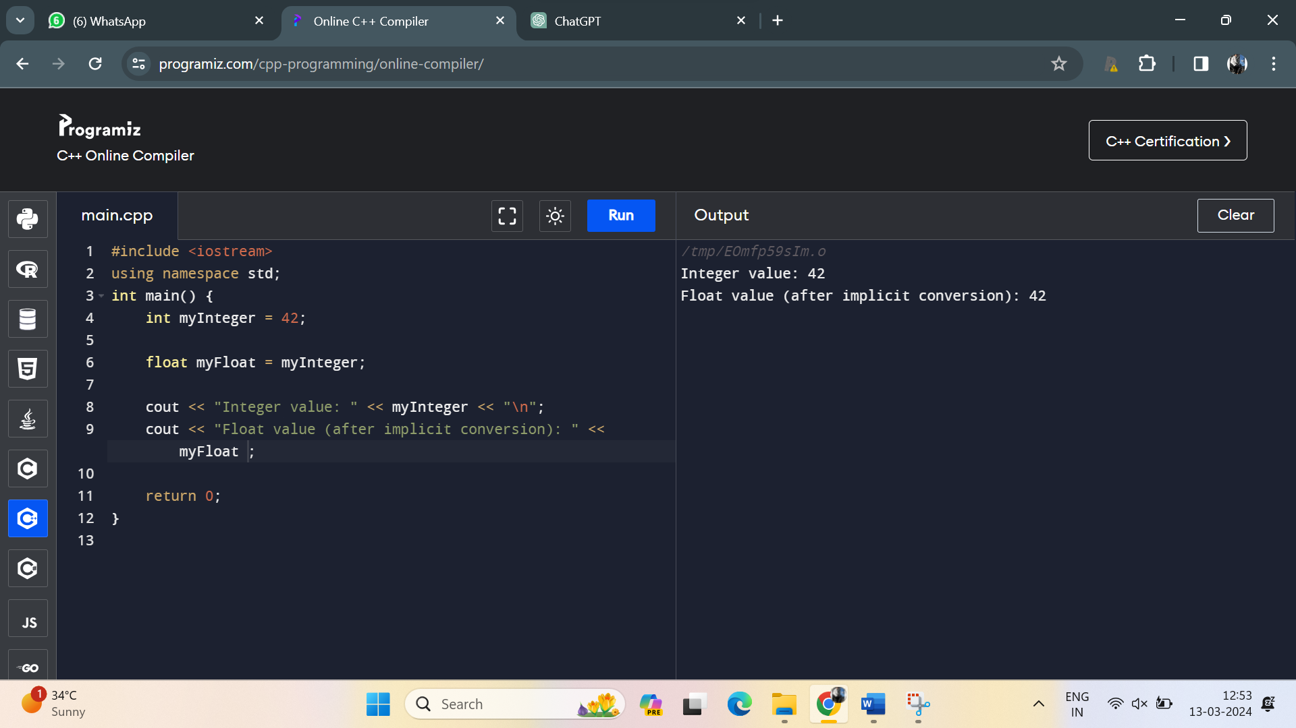

5. Write a C++ program to declare and initialize two integer variables and perform addition using the + operator

**Program**:

#include <iostream>

using namespace std;

int main() {

int a=10;

int b=20;

int sum=a+b;

cout<<"the sum is:"<<sum;

}

**Output**:

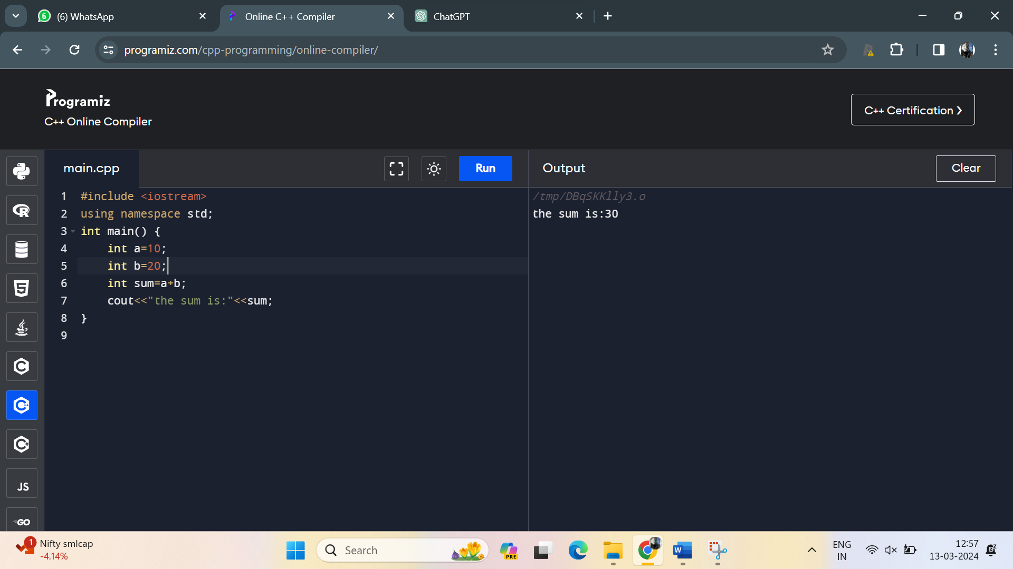

6. Create a C++ program to demonstrate the use of if-else control structure to determine if a number is even or odd

**Program**:

#include <iostream>

using namespace std;

int main() {

int a=10;

if(a%2==0)

{

cout<<"is an even number";

}

else

{

cout<<"is odd number";

}

}

**Output**:

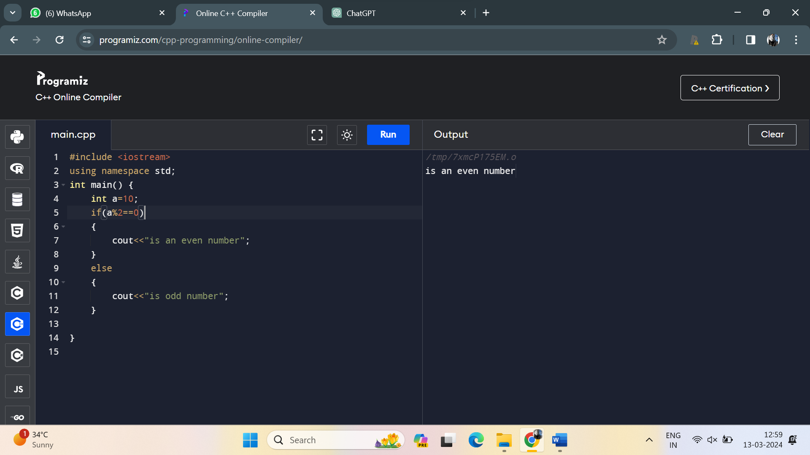

7. Write a C++ program to declare an array of integers and display its elements using a loop.

**Program**:

#include <iostream>

int main() {

const int arraySize = 5;

int myArray[arraySize] = {10, 20, 30, 40, 50};

std::cout << "Array elements:" << std::endl;

for (int i = 0; i < arraySize; ++i) {

std::cout << "Element " << i << ": " << myArray[i] << std::endl;

}

return 0;

}

**Output**:

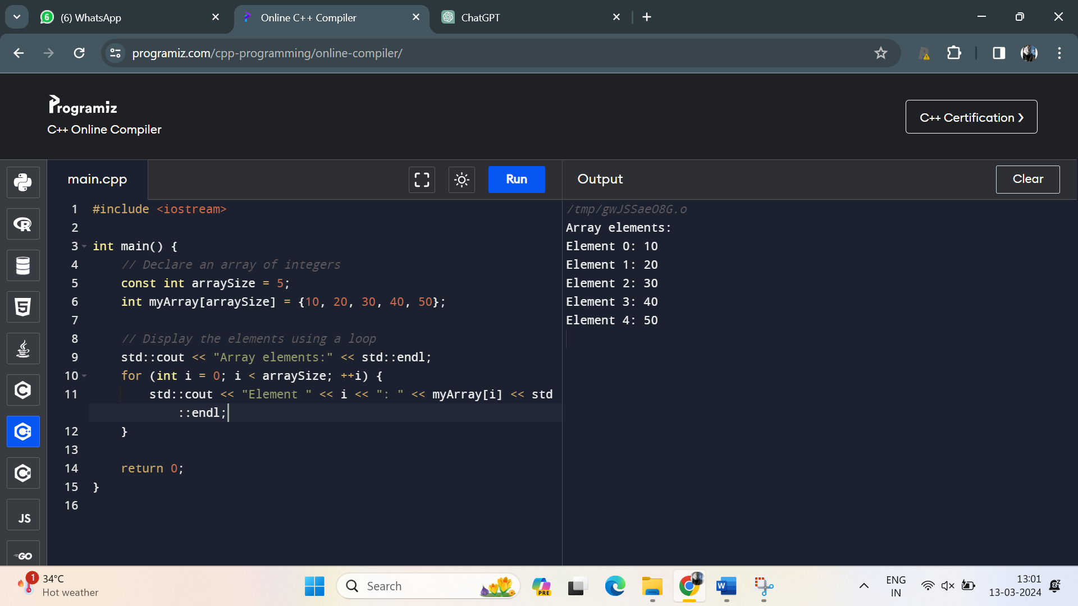

8. Implement a C++ program to demonstrate the use of switch-case control structure to display the name of the day based on the user input (1-7).

**Program**:

#include<iostream>

using namespace std;

int main(){

int n;

cout<<"enter the number between 1 to 7:";

cin>>n;

switch (n){

case 1:

cout<<"sunday"<<"\n";

break;

case 2:

cout<<"Monday"<<"\n";

break;

case 3:

cout<<"tuesday"<<"\n";

break;

case 4:

cout<<"wednsday"<<"\n";

break;

case 5:

cout<<"thursday"<<"\n";

break;

case 6:

cout<<"friday"<<"\n";

break;

case 7:

cout<<"saturday"<<"\n";

break;

}

return 0;

}

**Output**:

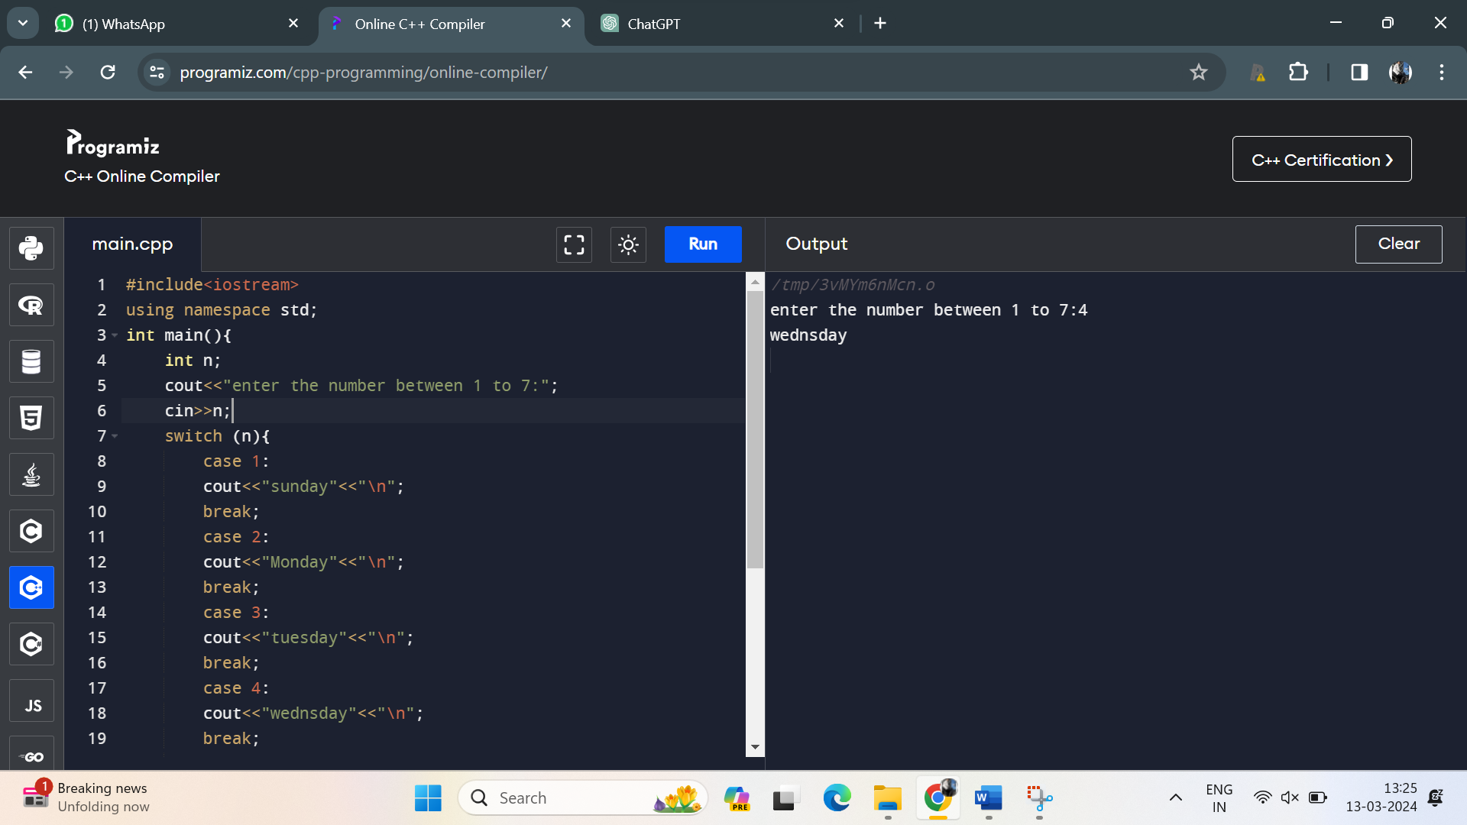

9. Create a C++ program to calculate the area of a rectangle using user input for length and width

**Program**:

#include<iostream>

using namespace std;

int main(){

int n=10;

int l=20;

int area=n*l;

cout<<"area of rectangle is:"<<area;

return 0;

}

**Output**:

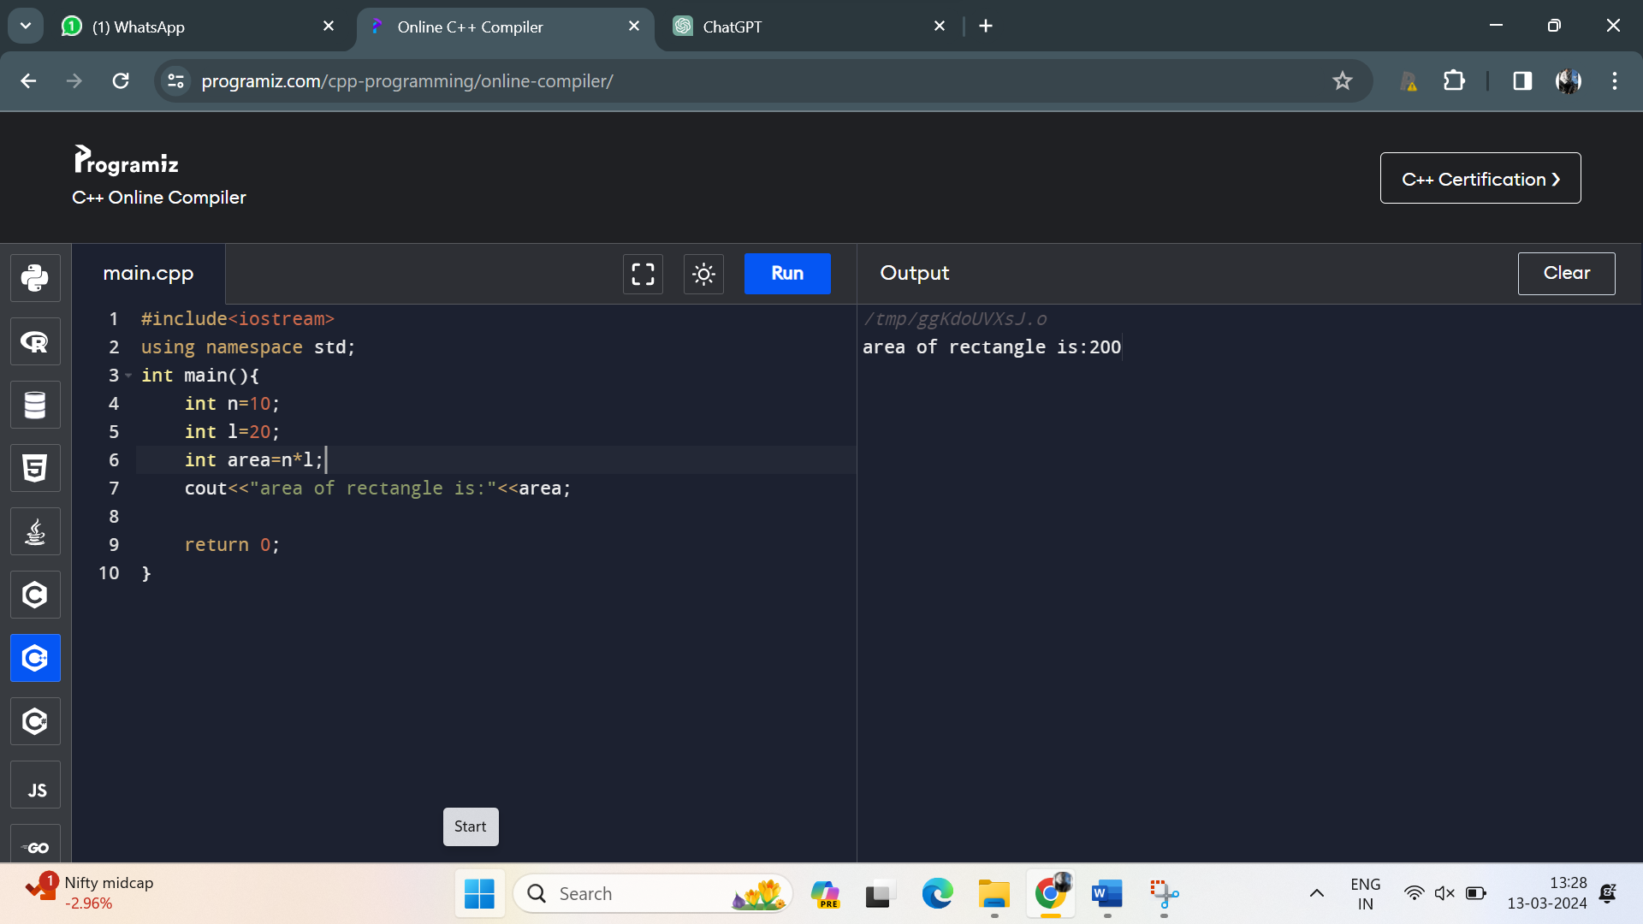

10. Write a C++ program to find the maximum of three numbers using conditional statements.

**Program:**

#include<iostream>

using namespace std;

int main() {

int num1, num2, num3;

cout << "Enter three numbers: ";

cin >> num1 >> num2 >> num3;

int maxNumber;

if (num1 >= num2 && num1 >= num3) {

maxNumber = num1;

} else if (num2 >= num1 && num2 >= num3) {

maxNumber = num2;

} else {

maxNumber = num3;

}

cout << "The maximum number is: " << maxNumber ;

return 0;

}

**Output**:

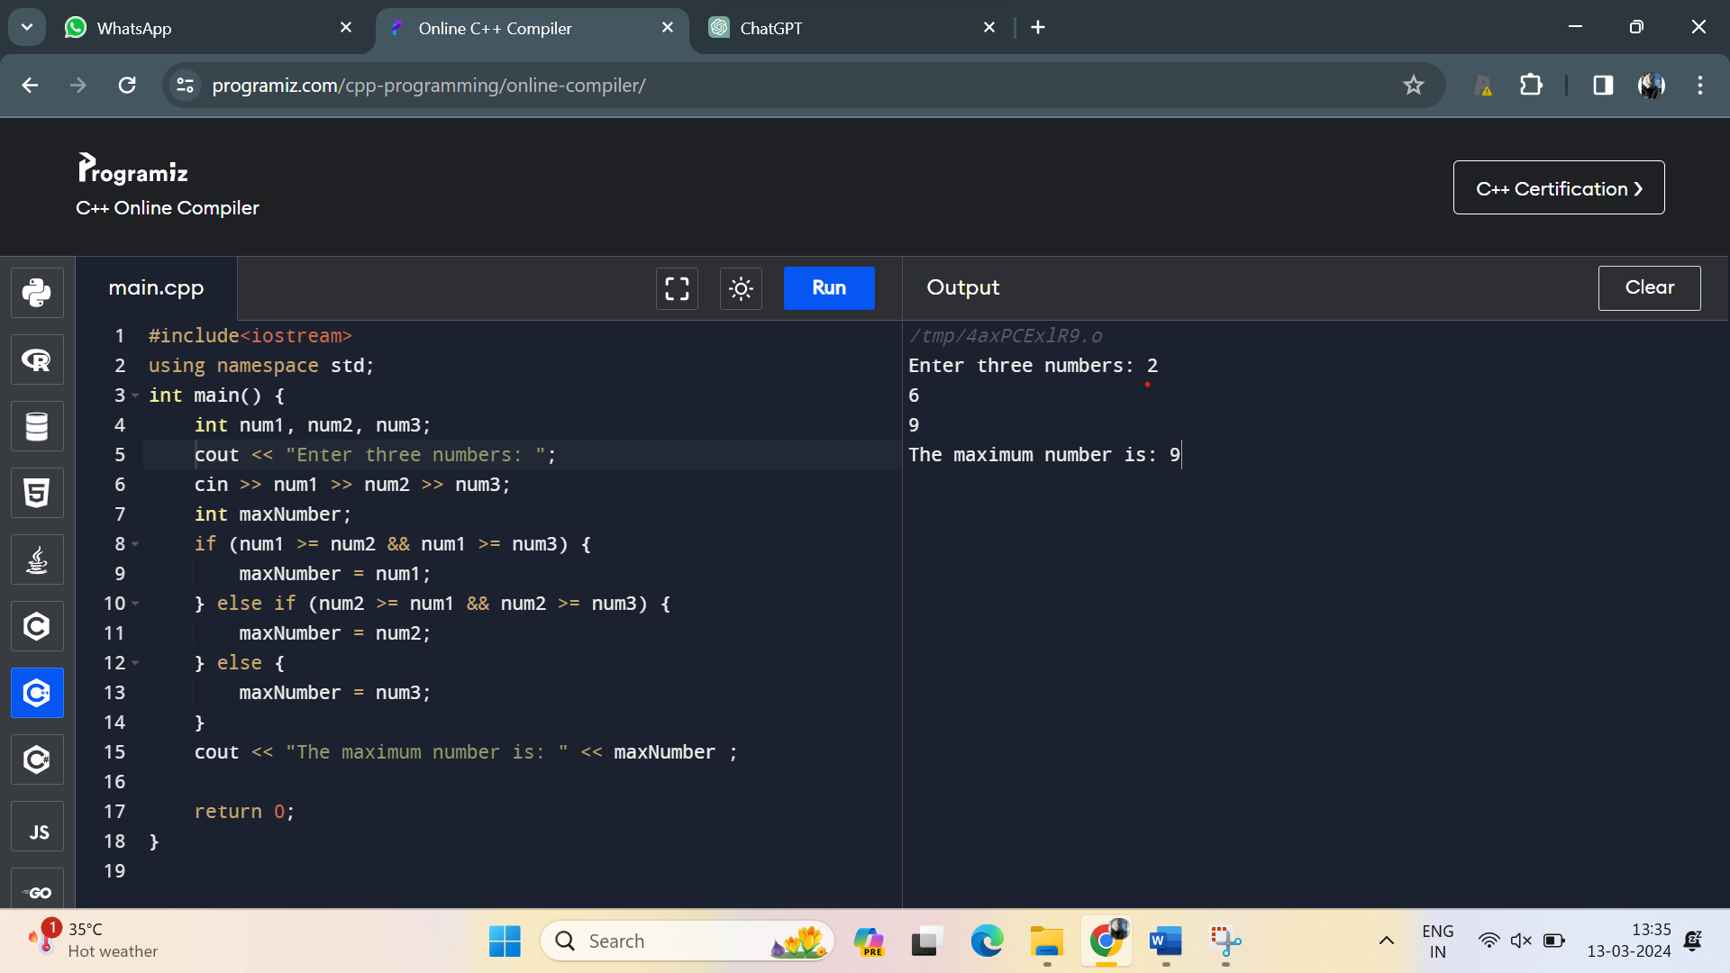

**Medium:**

111.Write a C++ program that calculates the area of a circle. Use a constant variable for the value of pi and prompt the user to enter the radius. Display the calculated area.

**Program:**

#include<iostream>

using namespace std;

int main(){

const double a=3.14;

int rad=5;

double area=a*rad*rad;

cout<<"the area of a circle is:"<<area;

return 0;

}

**Output**:

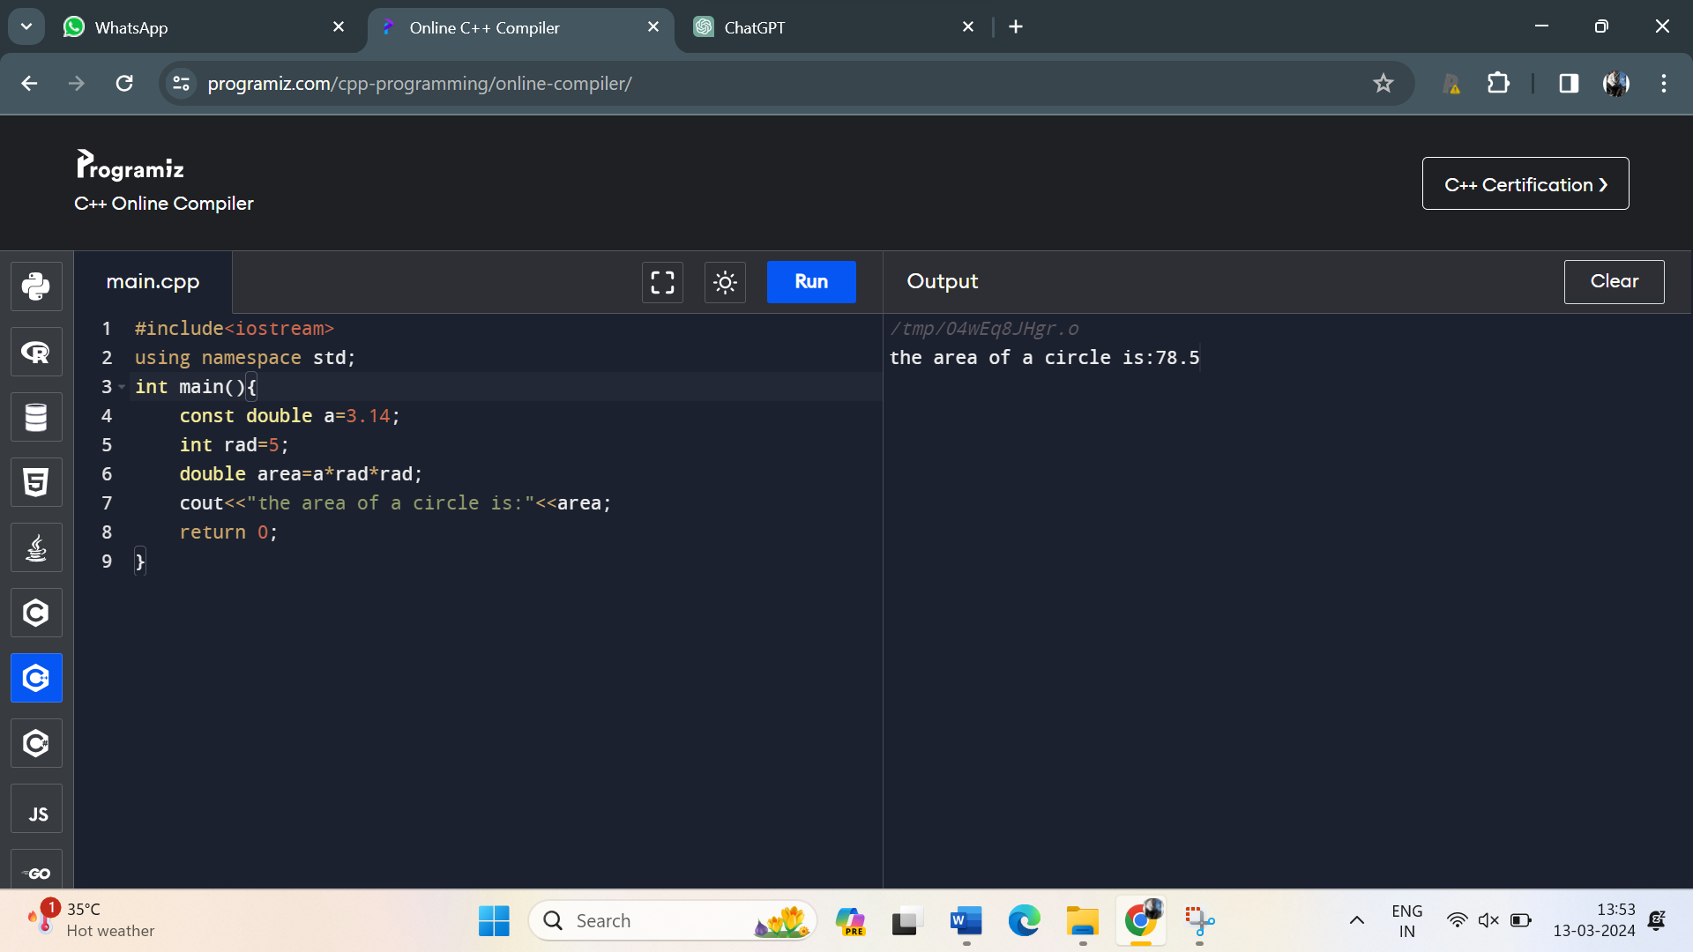

12. Develop a C++ program that reads two numbers from the user, one integer and one float. Perform division of the float by the integer and display the result. Ensure proper type compatibility and implicit conversion handling.

**Program:**

#include <iostream>

int main() {

int integerNumber;

float floatNumber;

std::cout << "Enter an integer: ";

std::cin >> integerNumber;

std::cout << "Enter a float: ";

std::cin >> floatNumber;

if (integerNumber != 0) {

float result = floatNumber / static_cast<float>(integerNumber);

std::cout << "Result of float / integer division: " << result << std::endl;

} else {

std::cout << "Error: Cannot divide by zero. Please enter a non-zero integer." << std::endl;

}

return 0;

}

Output:

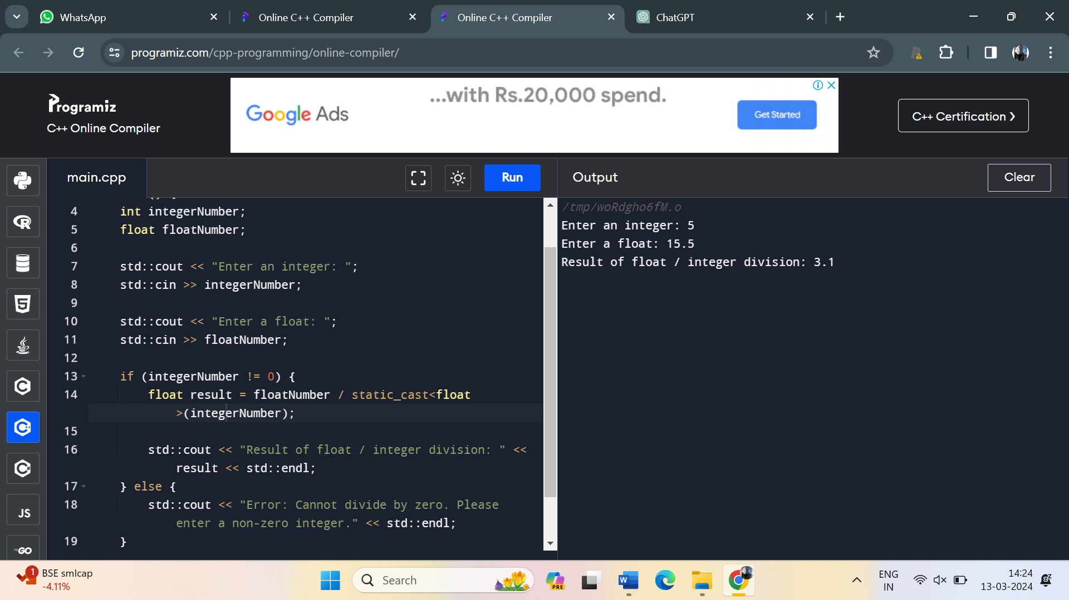

13. Write a C++ program to determine whether a given year is a leap year or not. Use logical operators and appropriate control structures to implement the leap year logic.

**Program:**

#include <iostream>

int main() {

int year;

std::cout << "Enter a year: ";

std::cin >> year;

if ((year % 4 == 0 && year % 100 != 0) || (year % 400 == 0)) {

std::cout << year << " is a leap year." << std::endl;

} else {

std::cout << year << " is not a leap year." << std::endl;

}

return 0;

}

**Output**:

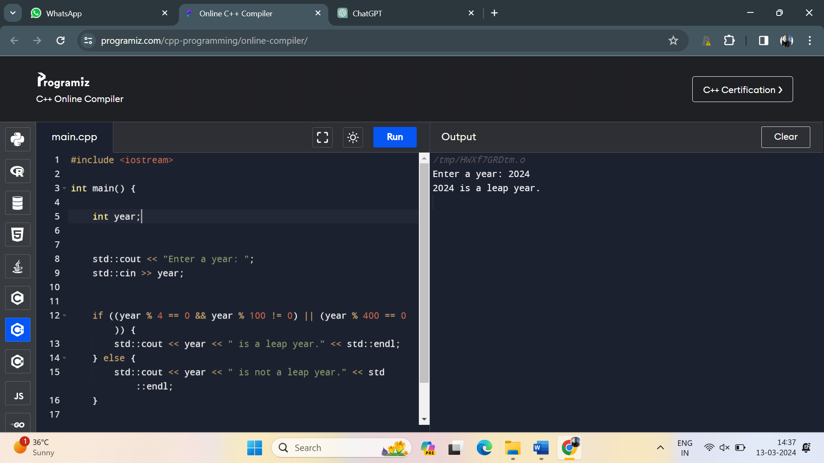

14. Create a C++ program that calculates the area of a rectangle. Prompt the user to enter the length and width of the rectangle as floating-point numbers, and display the calculated area.

Program:

#include <iostream>

int main() {

double length, width;

std::cout << "Enter the length of the rectangle: ";

std::cin >> length;

std::cout << "Enter the width of the rectangle: ";

std::cin >> width;

double area = length * width;

std::cout << "The area of the rectangle with length " << length

<< " and width " << width << " is: " << area << std::endl;

return 0;

}

Output:

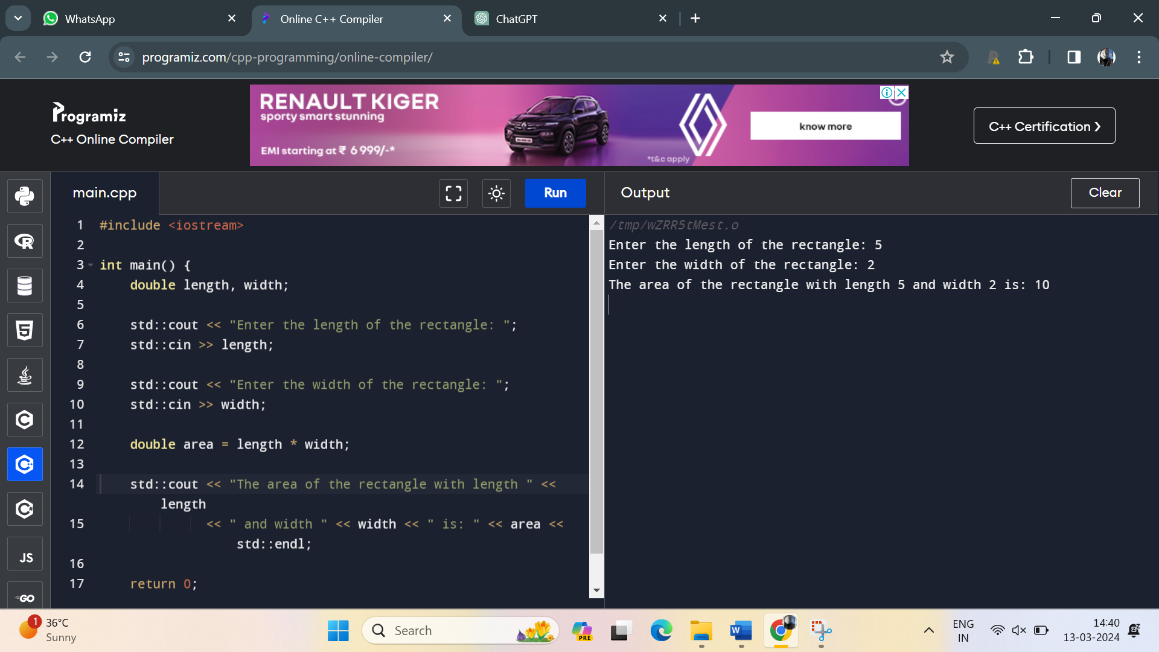

15. Develop a C++ program that reads an integer from the user and checks if it is an odd number. Use bitwise AND operator and handle implicit conversion properly.

Program:

#include <iostream>

int main() {

int userInput;

std::cout << "Enter an integer: ";

std::cin >> userInput;

if (userInput & 1) {

std::cout << userInput << " is an odd number." << std::endl;

} else {

std::cout << userInput << " is an even number." << std::endl;

}

return 0;

}

Output:

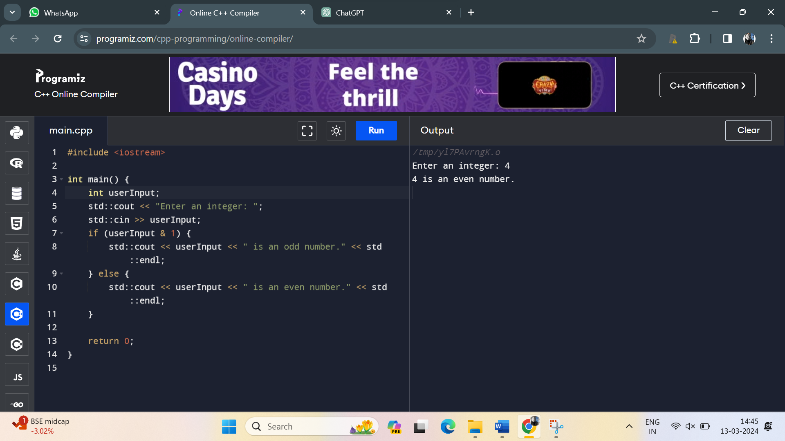

16. Write a C++ program that prompts the user to enter a month number (1-12) and displays the corresponding month name. Use a switch-case statement to implement this.

**Program:**

#include<iostream>

using namespace std;

int main(){

int n;

cout<<"enter the number:";

cin>>n;

switch (n){

case 1:

cout<<"january";

break;

case 2:

cout<<"Fiburary";

break;

case 3:

cout<<"March";

break;

case 4:

cout<<"Apriel";

break;

case 5:

cout<<"May";

break;

case 6:

cout<<"jun";

break;

case 7:

cout<<"july";

break;

case 8:

cout<<"August";

break;

case 9:

cout<<"September";

break;

case 10:

cout<<"October";

break;

case 11:

cout<<"November";

break;

case 12:

cout<<"December";

break;

}

return 0;

}

Output:

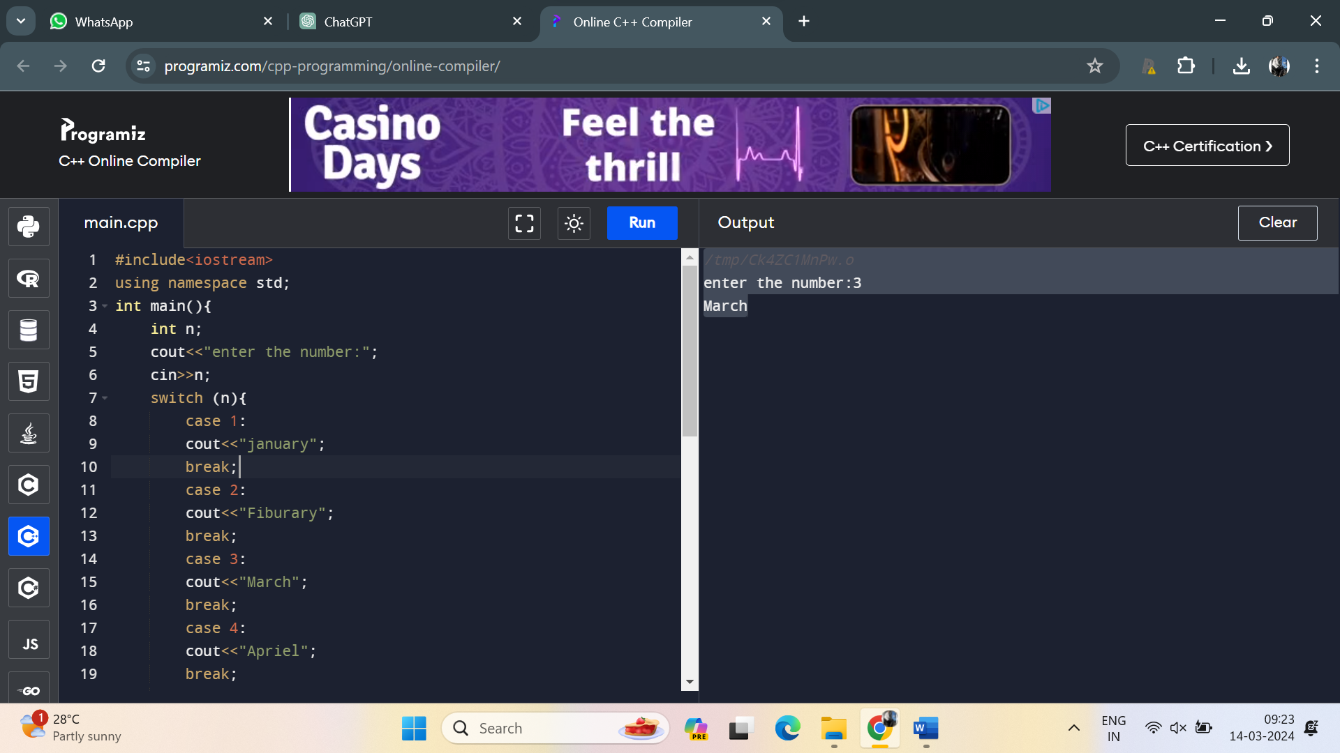

17. Create a C++ program that calculates the volume of a sphere. Prompt the user to enter the radius and use a constant variable for the value of pi. Display the calculated volume.

**Program:**

#include <iostream>

#include <cmath>

using namespace std;

int main() {

const double pi = 3.14159;

double radius, volume;

cout << "Enter the radius of the sphere: ";

cin >> radius;

volume = (4.0 / 3.0) * pi * pow(radius, 3);

cout << "The volume of the sphere is: " << volume << endl;

return 0;

}

Output:

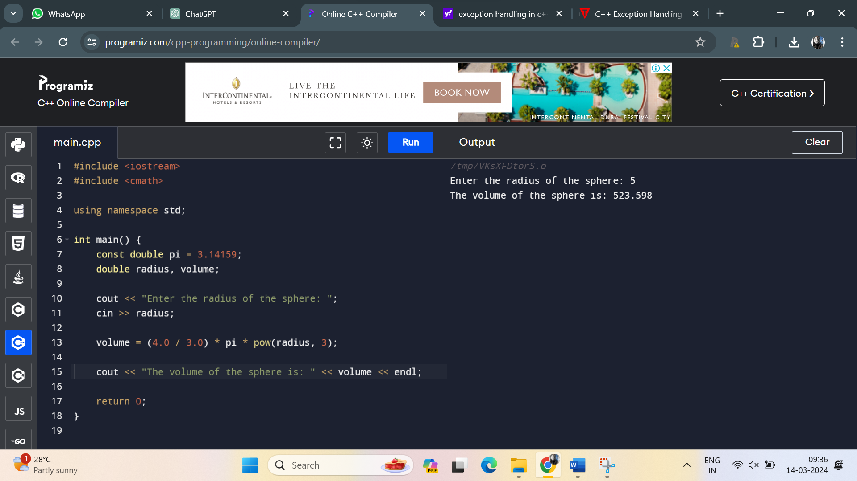

18. Develop a C++ program that reads two integers from the user and performs division. Ensure that if the second number is zero, the program should not crash, but display an appropriate error message

Program:

#include <iostream>

using namespace std;

int main() {

int dividend, divisor;

double result;

cout << "Enter the dividend: ";

cin >> dividend;

cout << "Enter the divisor: ";

cin >> divisor;

if (divisor == 0) {

cout << "Error: Division by zero is not allowed." << endl;

} else {

result = static_cast<double>(dividend) / divisor;

cout << "Result of division: " << result << endl;

}

return 0;

}

Output:

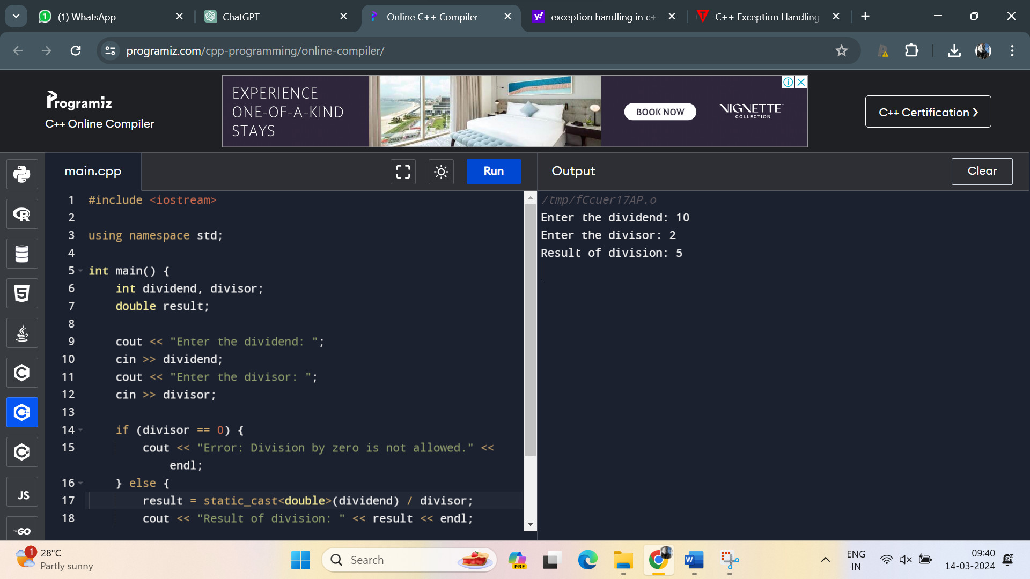

19. 9. Write a C++ program that defines a class representing a complex number. Implement operator overloading for addition and subtraction of complex numbers.

Program:

#include <iostream>

using namespace std;

class Complex {

private:

double real;

double imag;

public:

Complex(double r = 0.0, double i = 0.0) : real(r), imag(i) {}

// Overloading addition operator

Complex operator+(const Complex& other) const {

return Complex(real + other.real, imag + other.imag);

}

// Overloading subtraction operator

Complex operator-(const Complex& other) const {

return Complex(real - other.real, imag - other.imag);

}

// Function to display complex number

void display() const {

cout << real << " + " << imag << "i";

}

};

int main() {

Complex c1(3.0, 4.0); // 3 + 4i

Complex c2(1.0, 2.0); // 1 + 2i

// Addition

Complex addition = c1 + c2;

cout << "Addition: ";

addition.display();

cout << endl;

// Subtraction

Complex subtraction = c1 - c2;

cout << "Subtraction: ";

subtraction.display();

cout << endl;

return 0;

}

Output:

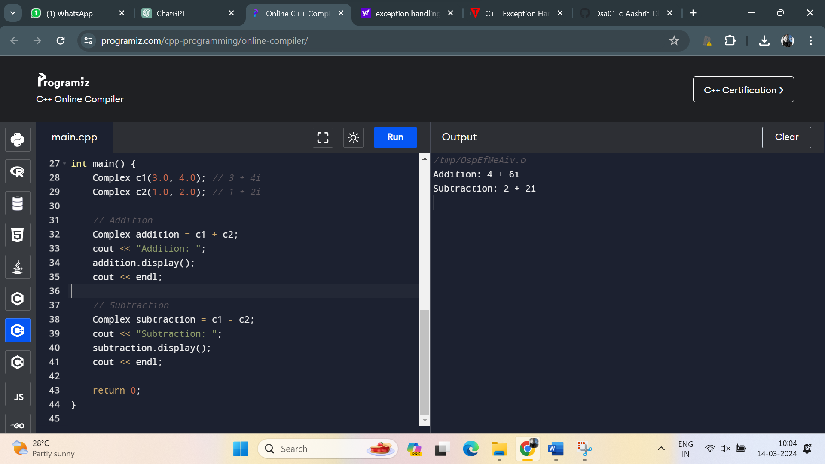

**20.** Create a C++ program that prompts the user to enter a number and calculates the factorial of that number using a loop. Display the result.

**Program:**

#include<iostream>

using namespace std;

int main(){

int fact=1,n,i;

cout<<"enter the number:";

cin>>n;

for (i=1;i<=n;i++)

{

fact=fact*i;

}

cout<<fact;

}

**Output:**

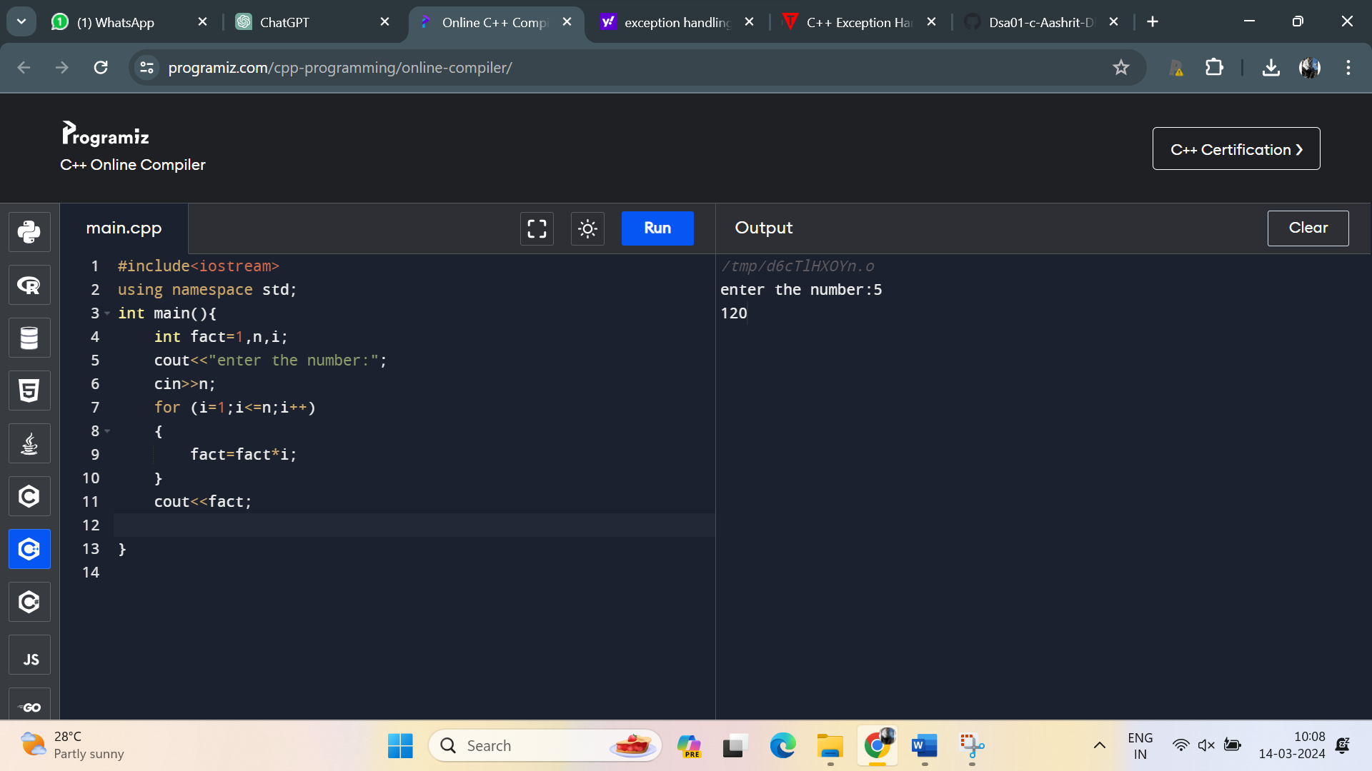

**21 .** Write a C++ program to implement a recursive function to calculate the Fibonacci sequence up to a given number 'n'.

**Program:**

#include <iostream>

using namespace std;

int fibonacci(int n) {

if (n <= 1)

return n;

else

return fibonacci(n - 1) + fibonacci(n - 2);

}

int main() {

int n;

cout << "Enter the number of terms in the Fibonacci sequence: ";

cin >> n;

cout << "Fibonacci sequence up to " << n << " terms:" << endl;

for (int i = 0; i < n; ++i) {

cout << fibonacci(i) << " ";

}

return 0;

}

**Output:**

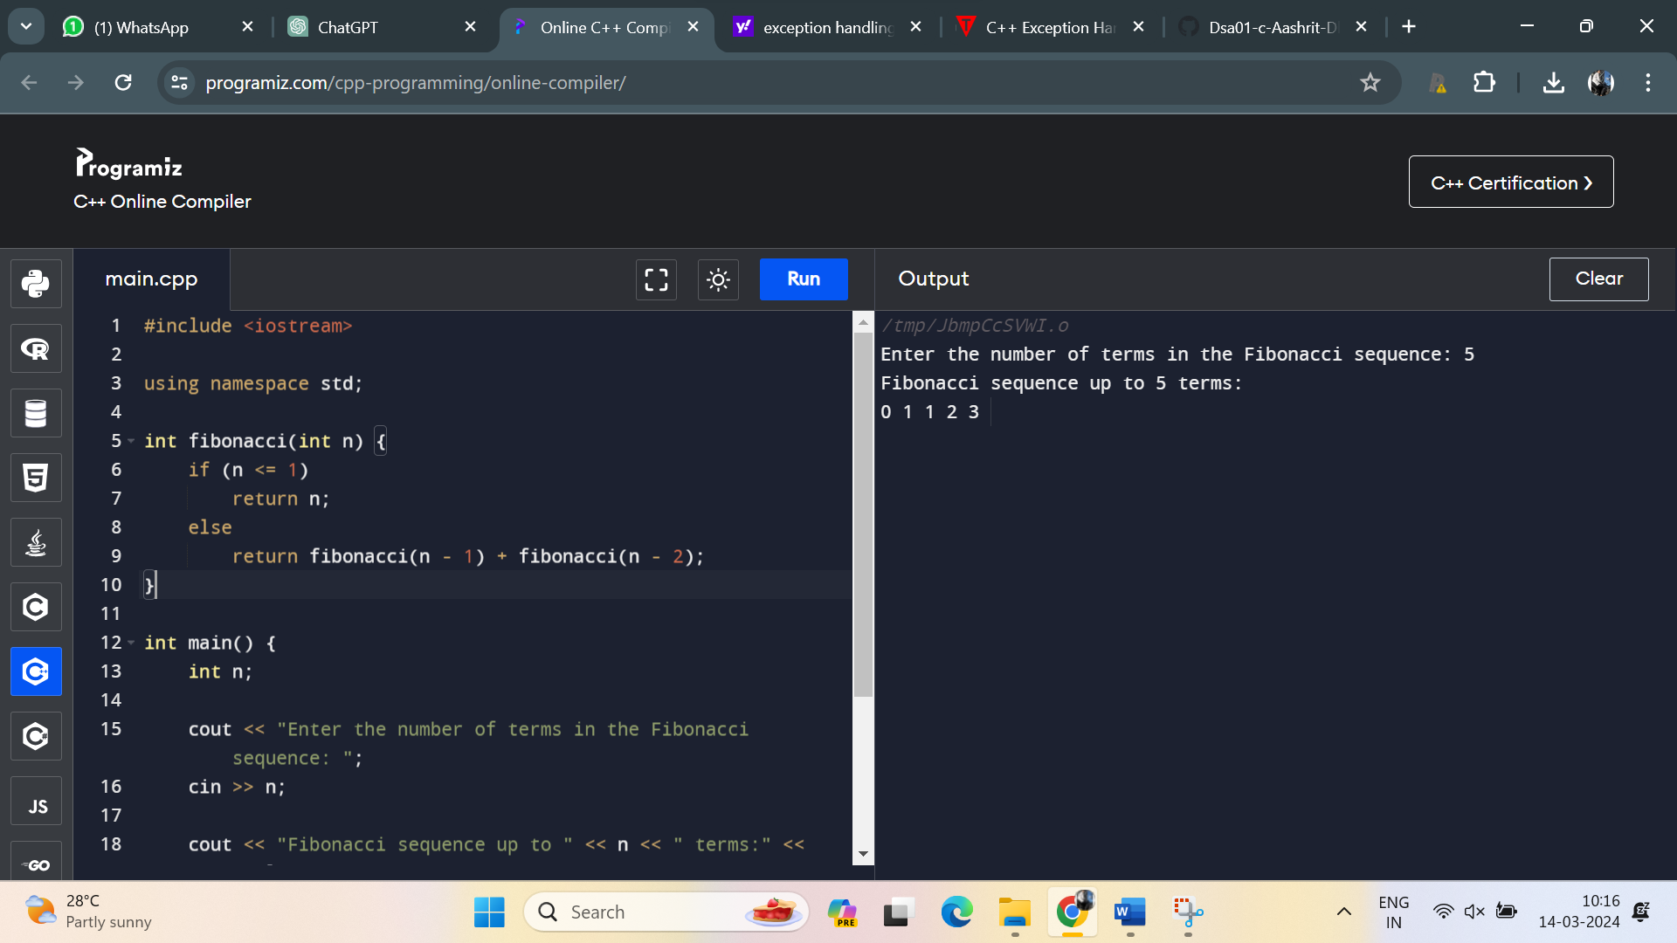

**22.** Develop a C++ program that dynamically allocates memory for an array of integers based on user input for the array size. Implement error handling for memory allocation failure.

**Program:**

#include <iostream>

using namespace std;

int main() {

int size;

// Prompting the user to enter the size of the array

cout << "Enter the size of the array: ";

cin >> size;

// Dynamically allocating memory for the array

int *arr = new (nothrow) int[size]; // Using 'nothrow' to prevent throwing exceptions on failure

// Checking if memory allocation was successful

if (arr == nullptr) {

cerr << "Failed to allocate memory!" << endl;

return 1; // Exiting the program with an error code

}

// Input elements for the array

cout << "Enter " << size << " integers for the array:" << endl;

for (int i = 0; i < size; ++i) {

cin >> arr[i];

}

// Displaying the elements of the array

cout << "Array elements:" << endl;

for (int i = 0; i < size; ++i) {

cout << arr[i] << " ";

}

cout << endl;

// Freeing the dynamically allocated memory

delete[] arr;

return 0;

}

**Output**:

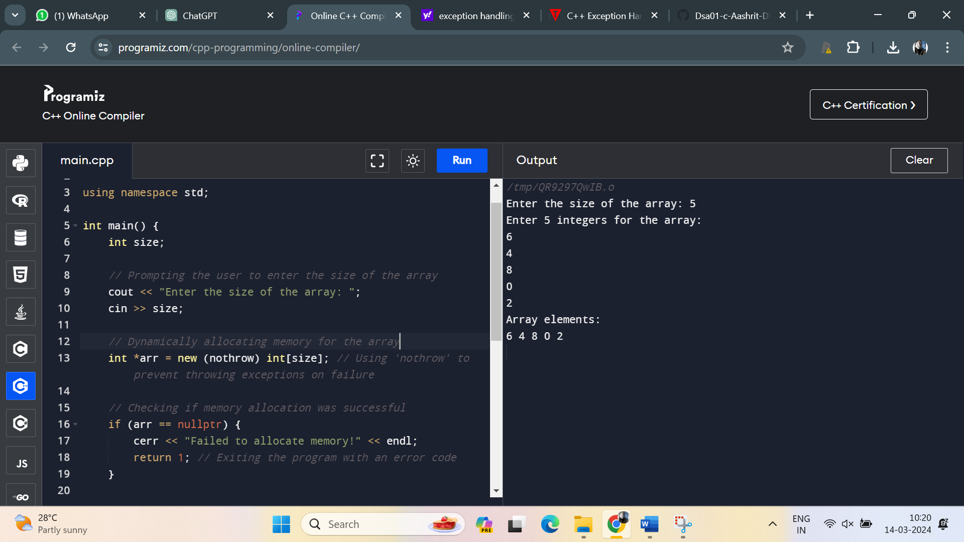

23. Create a C++ program that defines a class representing a matrix. Implement operator overloading for matrix addition, subtraction, and multiplication.

Program:

#include <iostream>

#include <vector>

using namespace std;

class Matrix {

private:

vector<vector<int>> mat;

size_t rows, cols;

public:

// Constructor

Matrix(size_t r, size_t c) : rows(r), cols(c), mat(vector<vector<int>>(r, vector<int>(c, 0))) {}

// Overloading addition operator

Matrix operator+(const Matrix& other) const {

if (rows != other.rows || cols != other.cols) {

cerr << "Error: Matrices must have the same dimensions for addition." << endl;

return *this; // Return the original matrix if dimensions don't match

}

Matrix result(rows, cols);

for (size_t i = 0; i < rows; ++i) {

for (size_t j = 0; j < cols; ++j) {

result.mat[i][j] = mat[i][j] + other.mat[i][j];

}

}

return result;

}

// Overloading subtraction operator

Matrix operator-(const Matrix& other) const {

if (rows != other.rows || cols != other.cols) {

cerr << "Error: Matrices must have the same dimensions for subtraction." << endl;

return *this; // Return the original matrix if dimensions don't match

}

Matrix result(rows, cols);

for (size_t i = 0; i < rows; ++i) {

for (size_t j = 0; j < cols; ++j) {

result.mat[i][j] = mat[i][j] - other.mat[i][j];

}

}

return result;

}

// Overloading multiplication operator

Matrix operator*(const Matrix& other) const {

if (cols != other.rows) {

cerr << "Error: Number of columns in the first matrix must be equal to the number of rows in the second matrix for multiplication." << endl;

return *this; // Return the original matrix if dimensions don't match

}

Matrix result(rows, other.cols);

for (size_t i = 0; i < rows; ++i) {

for (size_t j = 0; j < other.cols; ++j) {

for (size_t k = 0; k < cols; ++k) {

result.mat[i][j] += mat[i][k] * other.mat[k][j];

}

}

}

return result;

}

// Function to display the matrix

void display() const {

for (size_t i = 0; i < rows; ++i) {

for (size_t j = 0; j < cols; ++j) {

cout << mat[i][j] << " ";

}

cout << endl;

}

}

};

int main() {

// Create two matrices

Matrix mat1(2, 3);

Matrix mat2(3, 2);

// Initialize matrices

cout << "Enter elements for first matrix (2x3):" << endl;

for (size_t i = 0; i < 2; ++i) {

for (size_t j = 0; j < 3; ++j) {

cin >> mat1.mat[i][j];

}

}

cout << "Enter elements for second matrix (3x2):" << endl;

for (size_t i = 0; i < 3; ++i) {

for (size_t j = 0; j < 2; ++j) {

cin >> mat2.mat[i][j];

}

}

// Perform operations

cout << "Matrix addition:" << endl;

Matrix addition = mat1 + mat2;

addition.display();

cout << "Matrix subtraction:" << endl;

Matrix subtraction = mat1 - mat2;

subtraction.display();

cout << "Matrix multiplication:" << endl;

Matrix multiplication = mat1 * mat2;

multiplication.display();

return 0;

}

24. Write a C++ program that demonstrates function overloading for different data types. Create overloaded functions to calculate the area of a rectangle, circle, and triangle.

**Program**:

#include <iostream>

// Function to calculate the area of a rectangle

double area(double length, double width) {

return length * width;

}

// Function to calculate the area of a circle

double area(double radius) {

return 3.14159 * radius * radius;

}

// Function to calculate the area of a triangle

double area(double base, double height) {

return 0.5 * base * height;

}

int main() {

// Rectangle

double length = 5.0, width = 3.0;

std::cout << "Area of rectangle: " << area(length, width) << std::endl;

// Circle

double radius = 4.0;

std::cout << "Area of circle: " << area(radius) << std::endl;

// Triangle

double base = 6.0, height = 8.0;

std::cout << "Area of triangle: " << area(base, height) << std::endl;

return 0;

}

25. Develop a C++ program that evaluates mathematical expressions entered by the user, considering operator precedence and associativity. Support parentheses for grouping.

Program: #include <iostream>

#include <stack>

#include <string>

#include <cctype> // For isdigit()

using namespace std;

// Function to apply operator to operands

double applyOp(double a, double b, char op) {

switch (op) {

case '+': return a + b;

case '-': return a - b;

case '*': return a * b;

case '/': return a / b;

default: return 0.0;

}

}

// Function to evaluate the expression

double evaluateExpression(const string& expression) {

stack<double> values;

stack<char> ops;

for (char c : expression) {

if (c == ' ')

continue;

if (isdigit(c)) {

double val = 0;

while (isdigit(c)) {

val = val * 10 + (c - '0');

c = expression[++i];

}

values.push(val);

continue;

} else if (c == '(') {

ops.push(c);

} else if (c == ')') {

while (!ops.empty() && ops.top() != '(') {

double val2 = values.top(); values.pop();

double val1 = values.top(); values.pop();

char op = ops.top(); ops.pop();

values.push(applyOp(val1, val2, op));

}

if (!ops.empty()) ops.pop(); // Pop '('

} else {

while (!ops.empty() && ((c != '+' && c != '-') || (ops.top() == '*' || ops.top() == '/'))) {

double val2 = values.top(); values.pop();

double val1 = values.top(); values.pop();

char op = ops.top(); ops.pop();

values.push(applyOp(val1, val2, op));

}

ops.push(c);

}

}

while (!ops.empty()) {

double val2 = values.top(); values.pop();

double val1 = values.top(); values.pop();

char op = ops.top(); ops.pop();

values.push(applyOp(val1, val2, op));

}

return values.top();

}

int main() {

string expression;

cout << "Enter a mathematical expression: ";

getline(cin, expression);

double result = evaluateExpression(expression);

cout << "Result: " << result << endl;

return 0;

}

26. Write a C++ program that defines a template function to find the maximum element in an array of any data type. Test the function with integer, float, and double arrays

Program:

#include <iostream>

template<typename T>

T findMax(const T array[], int size) {

T maxElement = array[0];

for (int i = 1; i < size; ++i) {

if (array[i] > maxElement) {

maxElement = array[i];

}

}

return maxElement;

}

int main() {

// Integer array

int intArray[] = {3, 9, 2, 5, 7};

int intMax = findMax(intArray, 5);

std::cout << "Maximum element in integer array: " << intMax << std::endl;

// Float array

float floatArray[] = {3.5f, 9.2f, 2.7f, 5.1f, 7.8f};

float floatMax = findMax(floatArray, 5);

std::cout << "Maximum element in float array: " << floatMax << std::endl;

// Double array

double doubleArray[] = {3.5, 9.2, 2.7, 5.1, 7.8};

double doubleMax = findMax(doubleArray, 5);

std::cout << "Maximum element in double array: " << doubleMax << std::endl;

return 0;

}

Output:

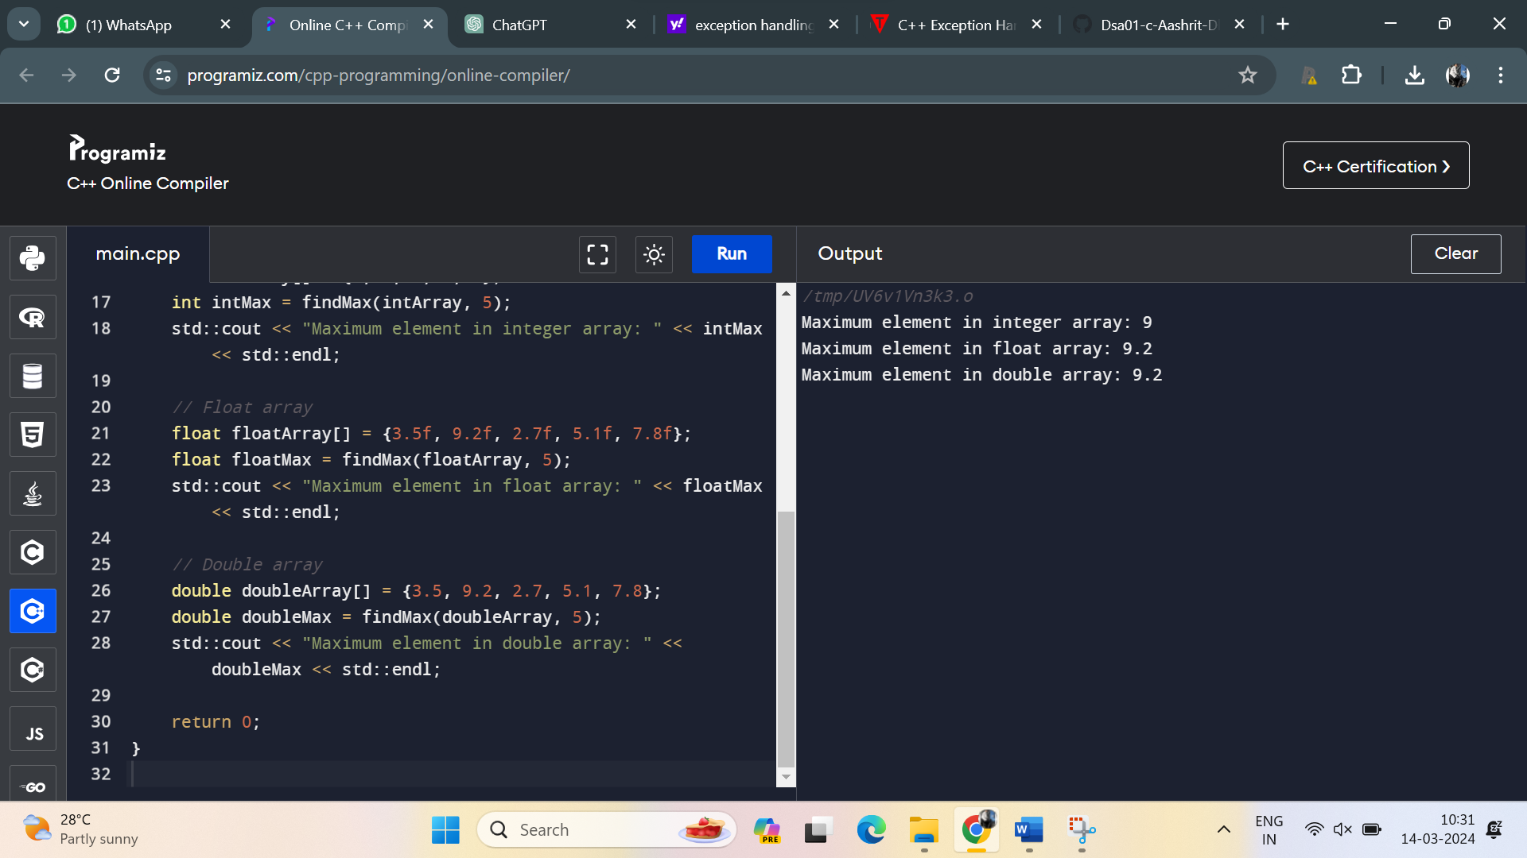

27. Create a C++ program to implement a recursive function to solve the Tower of Hanoi puzzle with 'n' disks.

Program:

#include <iostream>

// Function to move disks from source peg to destination peg

void towerOfHanoi(int n, char source, char destination, char auxiliary) {

if (n == 1) {

std::cout << "Move disk 1 from " << source << " to " << destination << std::endl;

return;

}

towerOfHanoi(n - 1, source, auxiliary, destination);

std::cout << "Move disk " << n << " from " << source << " to " << destination << std::endl;

towerOfHanoi(n - 1, auxiliary, destination, source);

}

int main() {

int n;

std::cout << "Enter the number of disks: ";

std::cin >> n;

towerOfHanoi(n, 'A', 'C', 'B');

return 0;

}

Output:

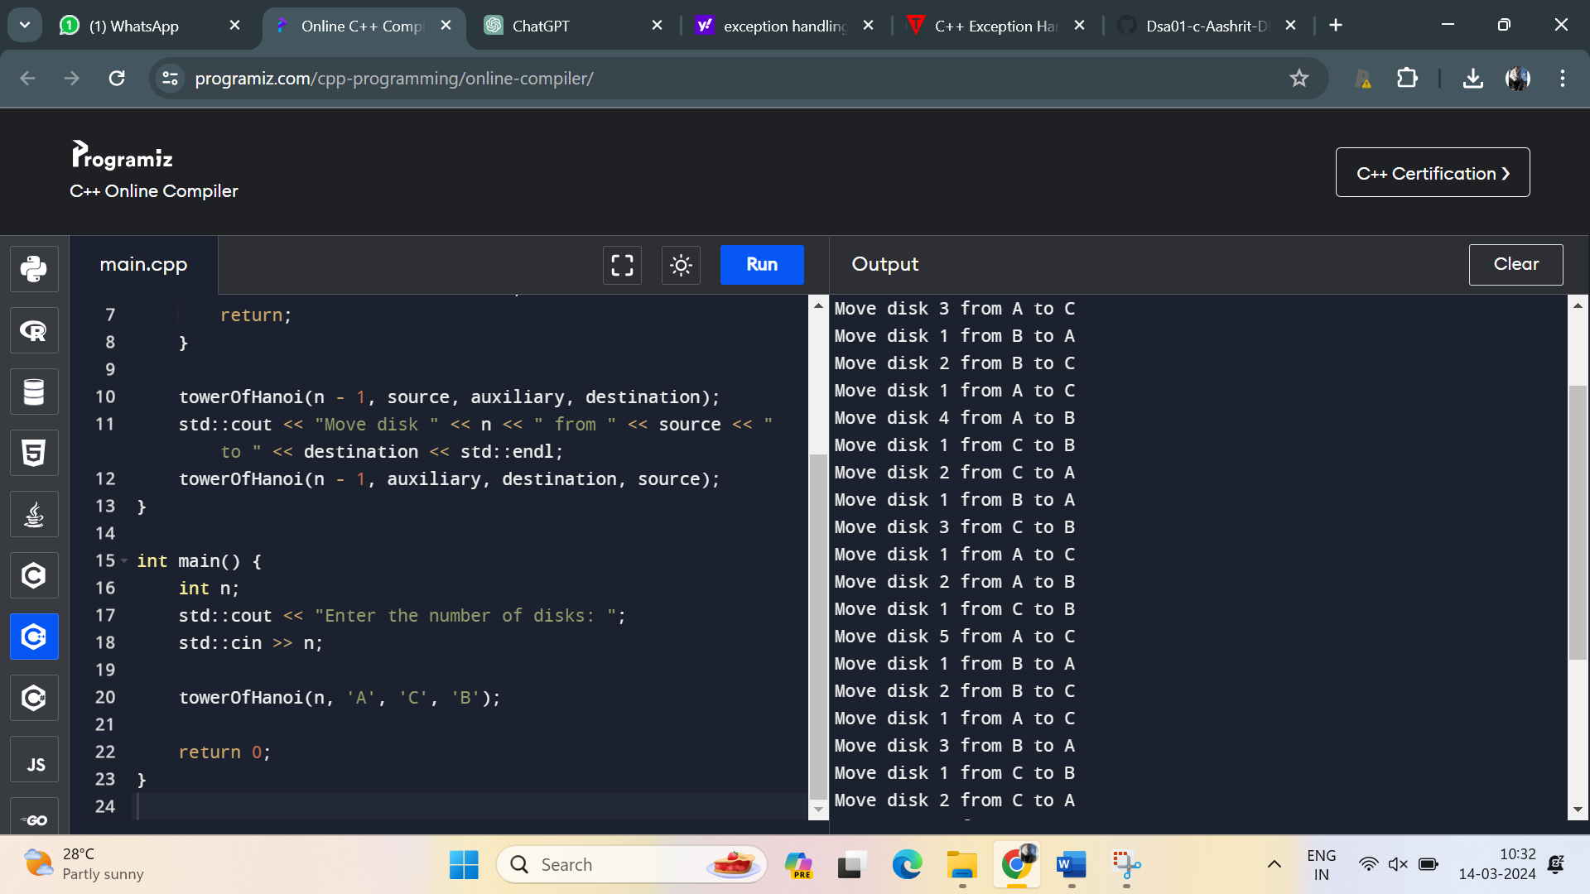

28. Develop a C++ program that reads input from a file containing numeric data and calculates the average. Implement exception handling to handle file I/O errors and invalid data.

Program:

#include <iostream>

#include <fstream>

#include <vector>

#include <stdexcept>

#include <sstream>

double calculateAverage(const std::string& filename) {

std::ifstream inputFile(filename);

if (!inputFile.is_open()) {

throw std::runtime_error("Error opening file");

}

std::vector<double> numbers;

std::string line;

while (std::getline(inputFile, line)) {

std::istringstream iss(line);

double num;

while (iss >> num) {

numbers.push_back(num);

}

}

if (numbers.empty()) {

throw std::runtime_error("No data found in the file");

}

double sum = 0;

for (double num : numbers) {

sum += num;

}

return sum / numbers.size();

}

int main() {

std::string filename;

std::cout << "Enter the filename: ";

std::cin >> filename;

try {

double average = calculateAverage(filename);

std::cout << "Average: " << average << std::endl;

} catch (const std::exception& e) {

std::cerr << "Error: " << e.what() << std::endl;

return 1;

}

return 0;

}

Output:

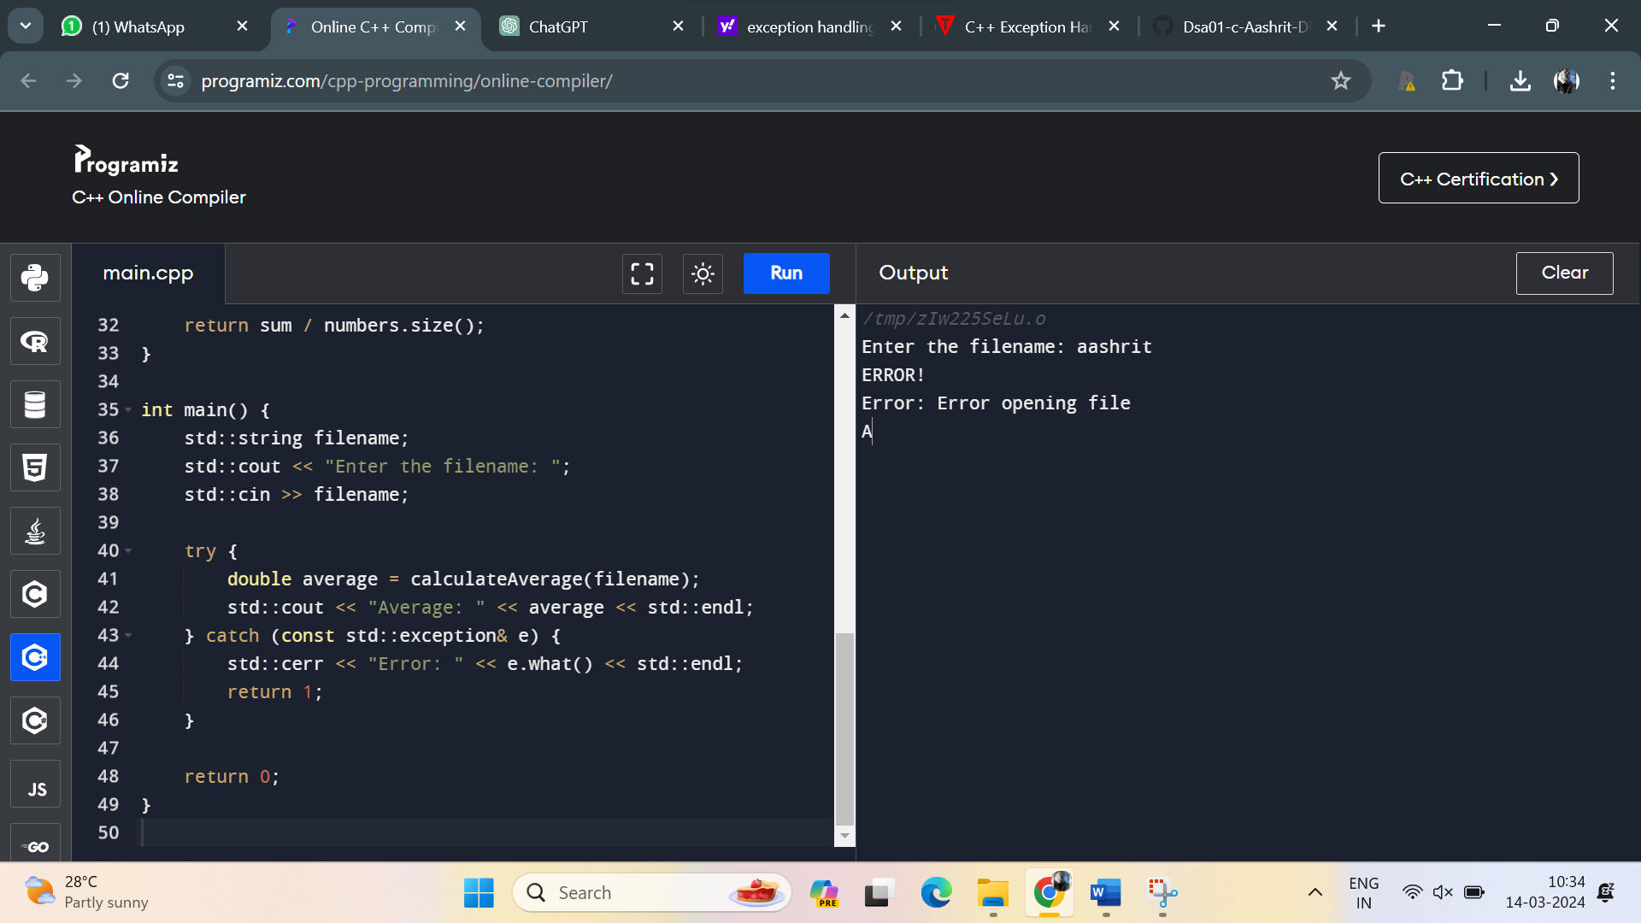

29. Write a C++ program that implements a callback mechanism using function pointers. Create a function that takes a callback function as an argument and calls it.

Program:

#include <iostream>

// Callback function type

typedef void (*CallbackFunction)(int);

// Function that takes a callback function as an argument and calls it

void performOperation(int value, CallbackFunction callback) {

std::cout << "Performing operation with value: " << value << std::endl;

callback(value * 2); // Calling the callback function with the modified value

}

// Callback function to be called

void callbackFunction(int value) {

std::cout << "Callback function called with value: " << value << std::endl;

}

int main() {

// Call performOperation with callbackFunction as the callback

performOperation(5, callbackFunction);

return 0;

}

Output:

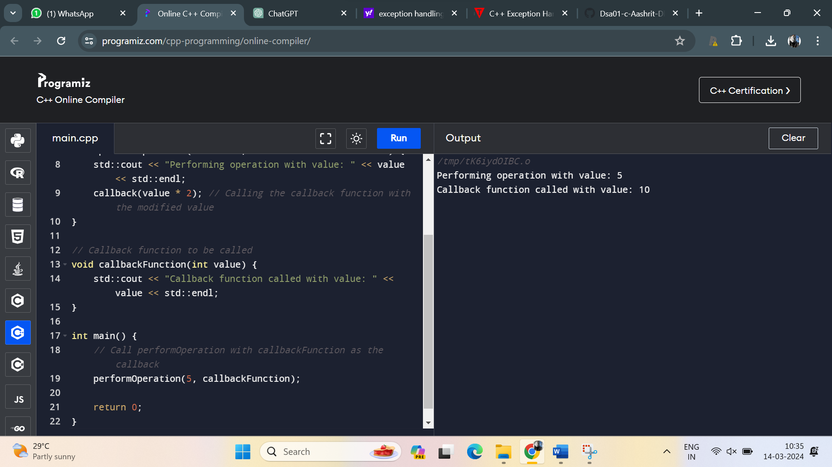

30. Develop a C++ program to implement a binary search tree (BST) and perform operations such as insertion, deletion, and traversal (in-order, pre-order, post-order).

Program:

#include <iostream>

// Node structure for BST

struct Node {

int key;

Node* left;

Node* right;

Node(int value) : key(value), left(nullptr), right(nullptr) {}

};

// Binary Search Tree class

class BST {

private:

Node* root;

// Private helper functions

Node* insertHelper(Node* node, int key);

Node* deleteHelper(Node* node, int key);

Node* minValueNode(Node* node);

void inorderTraversalHelper(Node* node);

void preorderTraversalHelper(Node* node);

void postorderTraversalHelper(Node* node);

void deleteTree(Node* node);

public:

BST() : root(nullptr) {}

~BST();

// Public member functions

void insert(int key);

void remove(int key);

void inorderTraversal();

void preorderTraversal();

void postorderTraversal();

};

// Destructor

BST::~BST() {

deleteTree(root);

}

// Private helper function to recursively delete the tree

void BST::deleteTree(Node* node) {

if (node != nullptr) {

deleteTree(node->left);

deleteTree(node->right);

delete node;

}

}

// Public function to insert a key into the BST

void BST::insert(int key) {

root = insertHelper(root, key);

}

// Private helper function to recursively insert a key into the BST

Node* BST::insertHelper(Node* node, int key) {

if (node == nullptr)

return new Node(key);

if (key < node->key)

node->left = insertHelper(node->left, key);

else if (key > node->key)

node->right = insertHelper(node->right, key);

return node;

}

// Public function to remove a key from the BST

void BST::remove(int key) {

root = deleteHelper(root, key);

}

// Private helper function to recursively remove a key from the BST

Node* BST::deleteHelper(Node* node, int key) {

if (node == nullptr)

return node;

if (key < node->key)

node->left = deleteHelper(node->left, key);

else if (key > node->key)

node->right = deleteHelper(node->right, key);

else {

if (node->left == nullptr) {

Node* temp = node->right;

delete node;

return temp;

} else if (node->right == nullptr) {

Node* temp = node->left;

delete node;

return temp;

}

Node* temp = minValueNode(node->right);

node->key = temp->key;

node->right = deleteHelper(node->right, temp->key);

}

return node;

}

// Private helper function to find the node with the minimum key value in a subtree

Node* BST::minValueNode(Node* node) {

Node* current = node;

while (current && current->left != nullptr)

current = current->left;

return current;

}

// Public function to perform in-order traversal of the BST

void BST::inorderTraversal() {

inorderTraversalHelper(root);

std::cout << std::endl;

}

// Private helper function to recursively perform in-order traversal of the BST

void BST::inorderTraversalHelper(Node* node) {

if (node != nullptr) {

inorderTraversalHelper(node->left);

std::cout << node->key << " ";

inorderTraversalHelper(node->right);

}

}

// Public function to perform pre-order traversal of the BST

void BST::preorderTraversal() {

preorderTraversalHelper(root);

std::cout << std::endl;

}

// Private helper function to recursively perform pre-order traversal of the BST

void BST::preorderTraversalHelper(Node* node) {

if (node != nullptr) {

std::cout << node->key << " ";

preorderTraversalHelper(node->left);

preorderTraversalHelper(node->right);

}

}

// Public function to perform post-order traversal of the BST

void BST::postorderTraversal() {

postorderTraversalHelper(root);

std::cout << std::endl;

}

// Private helper function to recursively perform post-order traversal of the BST

void BST::postorderTraversalHelper(Node* node) {

if (node != nullptr) {

postorderTraversalHelper(node->left);

postorderTraversalHelper(node->right);

std::cout << node->key << " ";

}

}

int main() {

BST bst;

// Insert some keys

bst.insert(50);

bst.insert(30);

bst.insert(20);

bst.insert(40);

bst.insert(70);

bst.insert(60);

bst.insert(80);

// Perform in-order traversal

std::cout << "In-order traversal: ";

bst.inorderTraversal();

// Perform pre-order traversal

std::cout << "Pre-order traversal: ";

bst.preorderTraversal();

// Perform post-order traversal

std::cout << "Post-order traversal: ";

bst.postorderTraversal();

// Remove a key

std::cout << "Remove key 30" << std::endl;

bst.remove(30);

// Perform in-order traversal after deletion

std::cout << "In-order traversal after deletion: ";

bst.inorderTraversal();

return 0;

}

Output:

